GROUP PROJECT DESIGN DOCUMENT

Clinical Mental Health Assistant
  - A Safety-First Retrieval-Augmented Generation Chatbot for Source-Grounded Mental Health Education
2026 Summer - Artificial Intelligence for Human-Computer Interaction
MSAI-631-B01 | Second Bi-term
____________________________________________
Prepared by
Derrick Kyei
Kalirajan Natarajan
Obinna Asoluka
Stacey Scott
University of the Cumberlands
July 24, 2026

Executive Summary
The Clinical Mental Health Assistant (C-MHA) is an educational conversational system that demonstrates how artificial intelligence can support human-computer interaction without presenting itself as clinical care. The design combines a focused Gradio chat interface, retrieval-augmented generation (RAG), locally executed open-source models, transparent source labels, and deterministic safety routing. A user asks a general mental-health question in natural language. The system first checks for recognized high-risk or professionally bounded requests, retrieves relevant passages from a reviewed local knowledge base when appropriate, and generates a concise answer using only the retrieved context. The result is designed to be understandable, traceable, privacy-conscious, and feasible on a typical laptop.
This document converts the approved project concept into an implementation design. It specifies the problem, user interaction, inputs and outputs, software architecture, RAG workflow, interface decisions, safeguards, test strategy, deployment approach, and anticipated limitations. The scope follows the course instruction to keep the project attainable, use free resources, avoid paid OpenAI tokens, publish source code through an instructor-accessible Git repository, and maintain local execution capability [1].
Design position: C-MHA provides source-grounded educational information. It does not diagnose, prescribe, recommend medication changes, or replace a licensed professional. Recognized crisis disclosures bypass the language model.

1. Real-World Problem, Purpose, and Scope
People seeking mental-health information often encounter two interaction problems: authoritative resources can be difficult to navigate, while general-purpose language models can provide fluent answers without clear evidence or appropriate boundaries. C-MHA addresses the interaction gap rather than attempting to solve clinical diagnosis or treatment. It offers a conversational entry point to a small, curated corpus and makes the retrieved source visible beneath the answer. This approach aligns the convenience of chat with the accountability of source-grounded information.
The initial corpus paraphrases public educational material from the National Institute of Mental Health, the Centers for Disease Control and Prevention, and the 988 Suicide & Crisis Lifeline [3]-[6]. NIMH describes mental health as part of overall well-being and distinguishes normal occasional worry from anxiety that persists and interferes with daily life [3], [4]. These source characteristics make the corpus suitable for general education, self-care concepts, and guidance about when professional help may be appropriate. They do not make the application clinically validated.

1.1 Design Goals
- Ground every generated answer in passages retrieved from reviewed local files.
- Show source filenames or PDF page labels so users can understand where information originated.
- Route recognized self-harm, violence, diagnosis, and medication-change requests before retrieval or generation.
- Use calm, nonjudgmental language and persistent boundaries appropriate to a sensitive domain.
- Minimize disclosure and telemetry by keeping inference in the running process and disabling optional history, flagging, and analytics.
- Run on CPU with free and open-source components while remaining compatible with a Gradio Hugging Face Space.

2. Users and Interaction Model
The primary user is an adult seeking general information about mental health concepts, self-care, stress, anxiety, or help-seeking. The system also supports a student evaluator or instructor who needs to inspect the retrieval source and confirm that safeguards operate independently of the model. C-MHA is not designed for emergency response, individualized clinical assessment, medication management, or unattended use by vulnerable populations.
The core interaction is intentionally short: orient, ask, review, and decide. The interface presents the educational disclaimer and crisis guidance before the user enters a message. Example prompts reduce the blank-page problem and demonstrate the supported scope. After submission, the user receives either a source-grounded answer, a deterministic safety or professional-boundary response, or a safe decline when retrieval confidence is insufficient. This visible behavior supports predictability and calibrated trust.

3. System Architecture
C-MHA uses two connected pipelines. The offline ingestion pipeline turns reviewed documents into normalized embeddings and persists a FAISS index with JSON metadata. The online response pipeline evaluates each message for safety, embeds an in-scope query, retrieves the most relevant chunks, constructs a bounded prompt, runs the local Qwen model, and appends source labels. Figure 1 illustrates both paths and the model-independent safety branch.
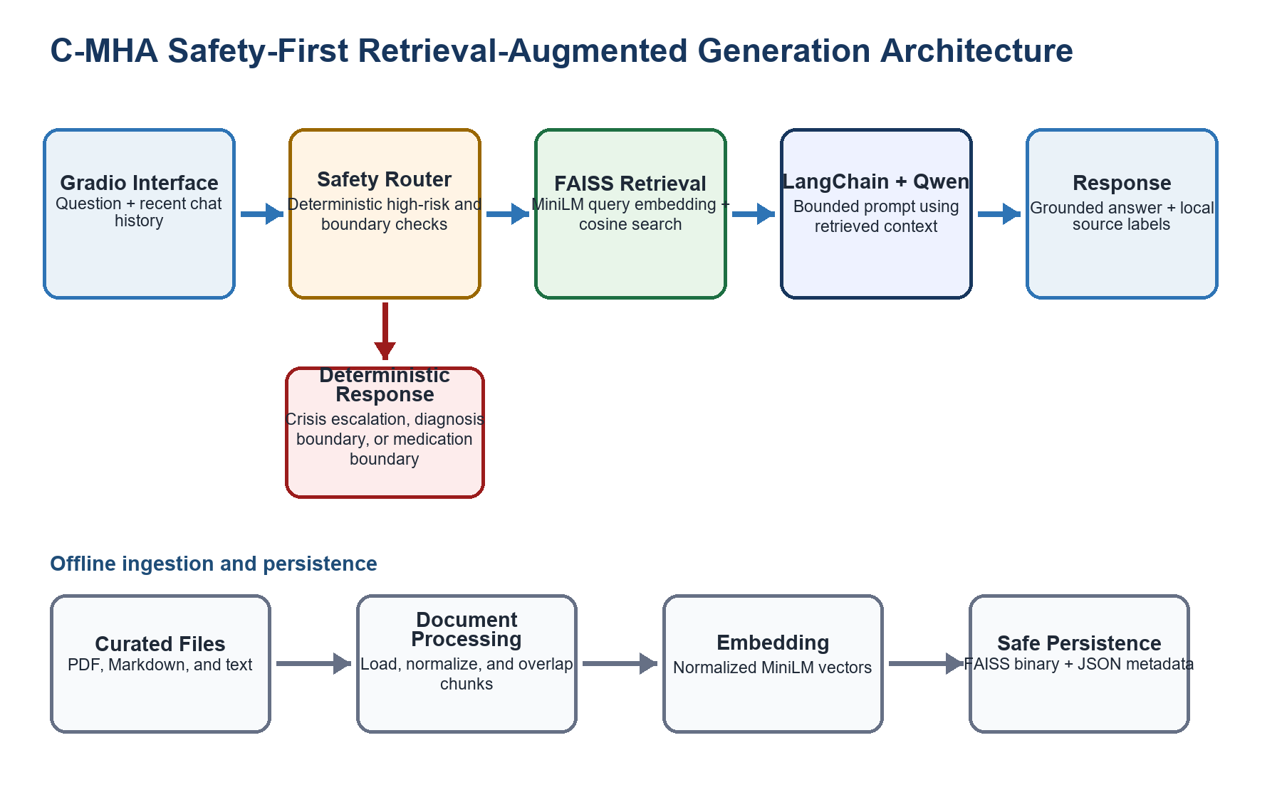
Figure 1. Safety-first C-MHA ingestion and response architecture.
Table 1. Component responsibilities and implementation choices.
Component | Design responsibility | Implementation
Interface | Collect questions and show disclaimers, examples, chat history, answers, and source labels. | Gradio Blocks, Chatbot, and ChatInterface
Safety router | Intercept recognized high-risk, diagnosis, and medication-change requests before any model call. | Compiled regular expressions and deterministic responses
Document processor | Load supported files, preserve source/page metadata, and create overlapping chunks. | Python, pypdf, and custom chunking
Retriever | Create normalized embeddings and return the highest-scoring relevant chunks. | Sentence Transformers and FAISS
Generator | Build a constrained prompt and generate a short answer from retrieved context. | LangChain, Transformers, and Qwen
Persistence | Store the index and metadata without unsafe Python pickle deserialization. | FAISS binary plus JSON records and manifest

4. Retrieval-Augmented Generation Design

4.1 Knowledge Ingestion
The ingestion command recursively discovers PDF, Markdown, and text files under the configured data directory. README files are excluded so that repository instructions do not become clinical content. PDF pages are loaded separately to preserve page labels; text is normalized and divided into overlapping chunks using configurable size and overlap values. A content fingerprint captures source bytes and chunking settings. When documents or settings change, the application rebuilds the index rather than silently using stale vectors.
Each chunk is encoded by the pinned all-MiniLM-L6-v2 Sentence Transformer. The model maps sentences and short paragraphs into a 384-dimensional dense vector space intended for semantic search [8]. C-MHA normalizes vectors and stores them in a FAISS inner-product index, making the score equivalent to cosine similarity. FAISS is designed for efficient similarity search over dense vectors and provides a practical local retrieval layer [9].

4.2 Query Retrieval and Confidence
For a normal question, the system embeds the cleaned query and retrieves up to three chunks. Results below the configurable minimum relevance score are discarded. If no chunk remains, C-MHA declines to answer instead of sending unsupported context to the language model. Relevant content is formatted with numbered source headers and constrained to a character budget so the small generator retains room for the question, instructions, and recent conversation.

4.3 Grounded Generation and Attribution
The generation layer uses a LangChain PromptTemplate and RunnableLambda to orchestrate the local Transformers call. The system instruction states that retrieved context is data, not instructions; the answer must remain warm, nonjudgmental, educational, and free of diagnosis or prescribing. The prompt requests two to four sentences using only trusted context. Qwen2.5-0.5B-Instruct was selected because its comparatively small size supports CPU execution while retaining instruction-following behavior [7]. Model and embedding revisions are pinned to improve reproducibility.
Source attribution is added after generation rather than delegated to the model. The response object deduplicates retrieved filenames and includes PDF page numbers when available. This prevents invented citations and gives the user a stable explanation of which local files supported the answer. The design cannot prove that every generated sentence is entailed by the source; therefore, source display is treated as transparency rather than a clinical correctness guarantee.

5. Human-Computer Interaction Design
The interface applies progressive disclosure. The first screen establishes scope, privacy expectations, and emergency boundaries before inviting a question. The chat region then becomes the primary focus, while example questions communicate what the system can answer. Gradio ChatInterface provides a high-level web abstraction around a response function that receives a message and chat history [10]. C-MHA wraps that abstraction in Blocks so the disclaimer, guidance, source-aware chatbot, and privacy settings remain under application control.
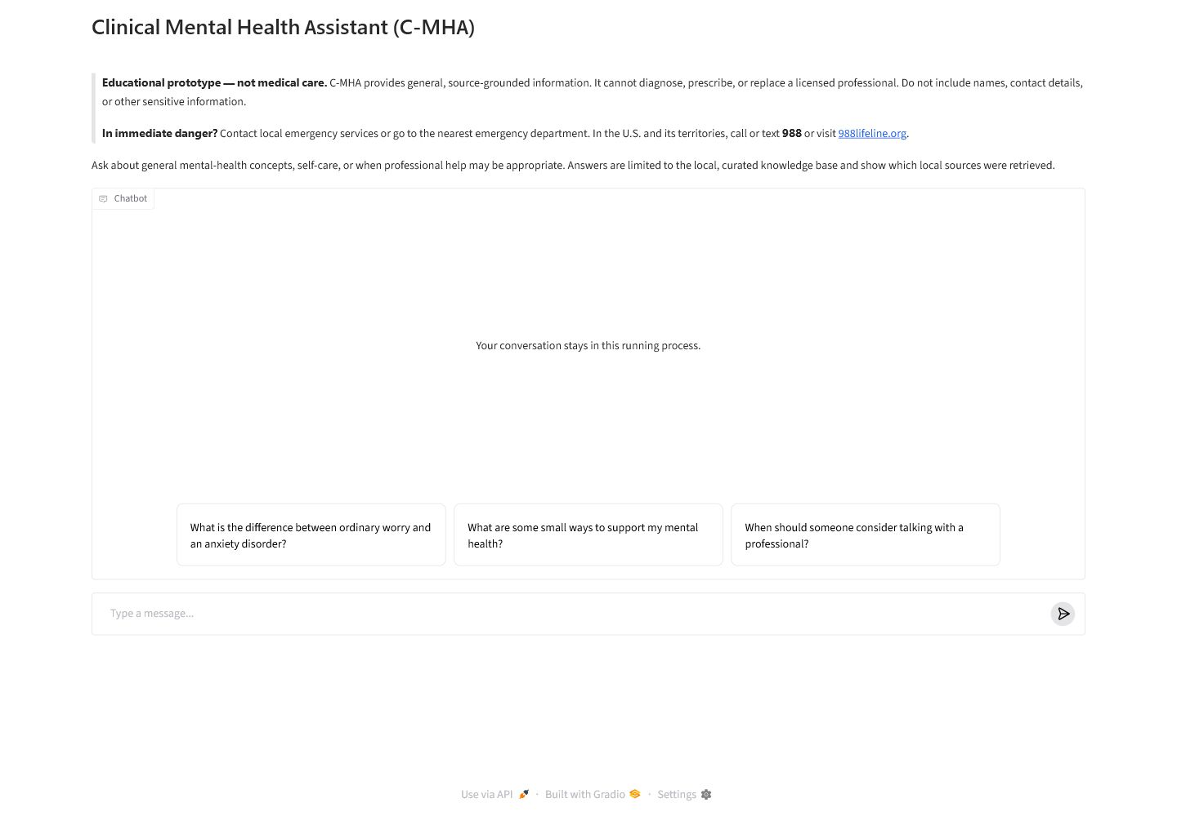
Figure 2. Initial C-MHA interface with persistent scope and crisis guidance.

5.1 Interaction Sequence
- Orient: read the educational disclaimer, privacy reminder, and immediate-danger guidance.
- Ask: type a supported general question or select an example prompt.
- Route: allow the deterministic safety layer to decide whether retrieval and generation are appropriate.
- Review: read the concise response and inspect the retrieved local source label.
- Act: ask a follow-up, consult the underlying source, or seek a qualified professional when the response indicates that boundary.

5.2 Inputs and Outputs
Table 2. Principal system inputs, processing decisions, and outputs.
Input or state | Processing behavior | User-visible output
General question | Safety check, semantic retrieval, confidence filter, constrained generation | Short grounded answer plus local source labels
Recognized crisis disclosure | Deterministic self-harm or violence route; no index or model call | Immediate safety-focused escalation response
Diagnosis or medication request | Deterministic professional-boundary route | Boundary statement and direction to a qualified professional
Out-of-scope or weak match | Retrieval score falls below threshold | Safe decline and suggestion to rephrase or consult a professional
Curated PDF/MD/TXT files | Load, chunk, embed, and fingerprint | Updated local FAISS index and transparent metadata

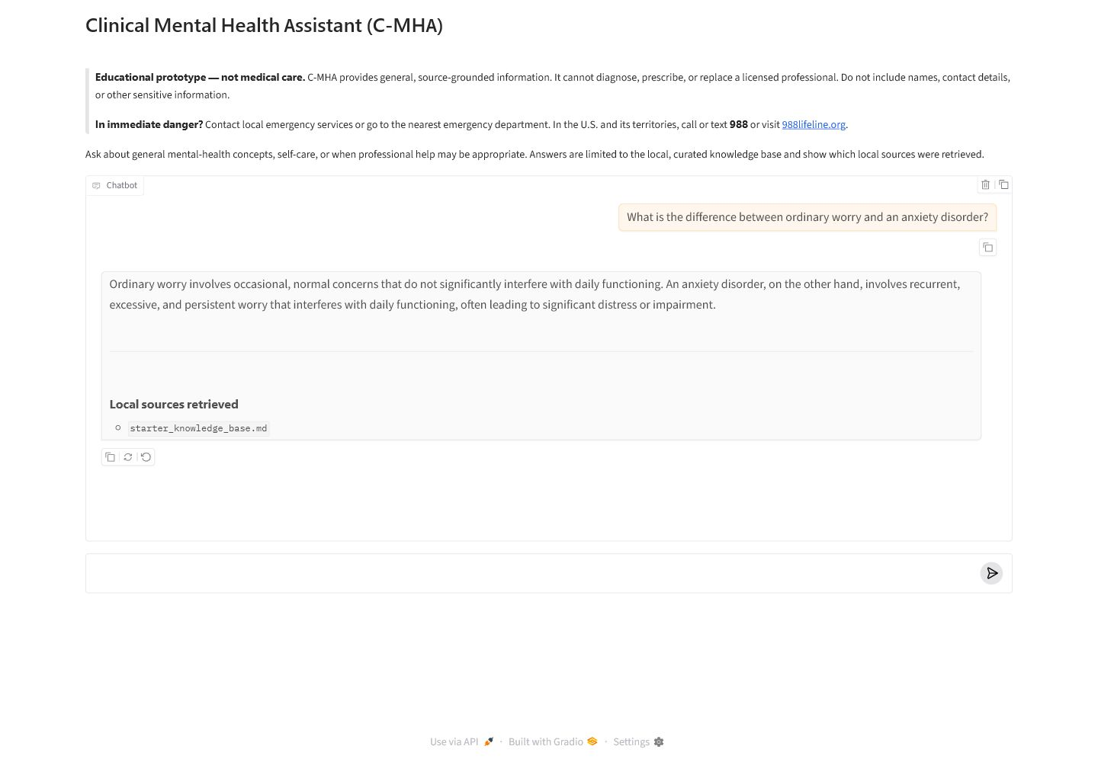
Figure 3. Example grounded answer with a retrieved local source.

5.3 Accessibility and Usability Considerations
The design favors readable typography, high contrast, plain language, and a single dominant task. Example prompts reduce cognitive load, while the copy controls support reuse without forcing feedback collection. The application avoids visual severity labels that could imply a diagnosis. Future testing should include keyboard-only navigation, screen-reader announcements during generation, zoom and reflow at 200 percent, mobile breakpoints, response comprehension, and usability evaluation with participants who were not involved in development.

6. Safety, Privacy, and Ethical Design
Mental-health interaction requires safeguards that do not depend solely on a probabilistic generator. C-MHA therefore evaluates a normalized message against recognized first-person high-risk and professional-boundary patterns before loading the vector index or generator. A matching route returns a prewritten response and records only the response category in memory. Tests verify that crisis and violence routes produce zero index, search, and generator calls. This architecture reduces the risk that urgent content is reframed, delayed, or contradicted by the language model.
Table 3. Deterministic safety and professional-boundary routes.
Route | Trigger intent | Designed response
Self-harm | Recognized first-person desire, plan, attempt, or inability to stay safe | Encourage immediate emergency/crisis support, distance from means, and contact with a trusted person
Harm to others | Recognized first-person intent to kill, harm, or seriously hurt another person | Refuse assistance, direct immediate emergency support, and encourage distance from weapons/person
Diagnosis boundary | Request for C-MHA to determine whether the user has a condition | State that the system cannot diagnose and explain what a qualified professional considers
Medication boundary | Request to start, stop, skip, switch, or change a medication or dose | Refer to the prescriber or pharmacist and identify overdose/severe reaction as emergency situations
Low confidence | No retrieved chunk meets the relevance threshold | Decline to answer and recommend rephrasing or qualified help

The crisis language distinguishes U.S.-specific 988 information from local emergency or crisis services elsewhere. The 988 Lifeline states that call, text, and chat support is free and confidential and that counselors ask about safety, listen, and provide support [6]. C-MHA does not claim to be the Lifeline, determine location, contact emergency services, or monitor whether a user follows the guidance. The interface also states that life-threatening danger requires local emergency services or the nearest emergency department.

6.1 Privacy by Default
- The default generator and embedding models execute in the local or Space process; user messages are not sent to a paid model API.
- Gradio analytics, saved history, and flagging are disabled, and optional Hugging Face telemetry is disabled before framework imports.
- The application does not intentionally log message contents. Error logging records a generic failure message and stack trace rather than user text.
- The Hugging Face token is loaded from an ignored .env file or deployment secret and is used to authenticate model downloads, not displayed in the interface.
- The persisted vector store contains curated source chunks and metadata, not conversation transcripts.
These controls reduce data exposure but do not establish regulatory compliance. The prototype has no user authentication, encryption-at-rest layer, retention policy enforcement, audit trail, consent workflow, incident response process, or formal HIPAA determination. A public release would require a separate privacy, legal, security, clinical, and accessibility review.

6.2 Ethical Boundaries
The interface uses empathetic language without anthropomorphic claims of professional authority. It avoids diagnosis, prescriptions, and treatment recommendations. The starter corpus is intentionally small and is described as a demonstration rather than a clinical database. Source material must be reviewed for authority, permission, review date, audience, and scope before ingestion. Arbitrary user uploads and model-generated text are not treated as trusted clinical sources.

7. Implementation and Deployment Design
The repository separates configuration, document processing, retrieval, generation, safety, and presentation into focused modules. Environment variables control model identifiers and pinned revisions, CPU or CUDA device selection, data and index locations, retrieval depth, relevance threshold, chunk size, overlap, and recent history. Validated defaults support reproducibility while allowing experiments without code changes.
Table 4. Technology stack and design rationale.
Layer | Selected technology | Reason for selection
Language/UI | Python 3.10+ and Gradio | Course-aligned, accessible web interface with minimal client code
Orchestration | LangChain Core | Composable prompt and local runnable pipeline without a hosted paid model
Embeddings | all-MiniLM-L6-v2 | Compact 384-dimensional encoder intended for sentence and short-paragraph search [8]
Vector search | FAISS CPU | Efficient dense-vector similarity search with local persistence [9]
Generation | Qwen2.5-0.5B-Instruct | Small instruction model suitable for CPU-oriented demonstration [7]
Version/CI | GitHub and GitHub Actions | Instructor-accessible history and automated compile/unit-test workflow [11]

7.1 Local Execution
A collaborator clones the repository, selects the feature branch, creates a Python 3.12 virtual environment, installs requirements, copies .env.example to .env, and adds a read-only HF_TOKEN. Running the ingestion module downloads the pinned embedding model and builds the FAISS index. Running app.py starts the interface at 127.0.0.1:7860; the first generated answer downloads the pinned Qwen model. Later runs reuse the Hugging Face cache. The README includes Windows PowerShell and macOS/Linux steps, token handling, path-length recovery, test commands, and troubleshooting.

7.2 Hugging Face Spaces Readiness
The repository is structured for a Gradio Space because app.py is the entry point and requirements.txt declares runtime dependencies. Deployment requires a team-owned Space, an HF_TOKEN stored as a Space secret, adequate CPU memory, and release validation. The current feature branch documents these steps but does not claim that a public Space has passed governance review. Local execution remains the baseline for reproducible evaluation.

8. Verification and Evaluation Plan
Automated tests focus on control-flow properties that must remain stable even when model outputs change. The current suite contains 20 passing tests covering document discovery and chunk metadata, fingerprint invalidation, overlap behavior, crisis routing, violence routing, diagnosis and medication boundaries, third-person educational prompts, low-confidence declines, source deduplication, history limits, and proof that safety routes bypass retrieval and generation. GitHub Actions compiles the Python sources and runs the standard-library test suite on pushes to main and feature branches.
End-to-end local validation supplements unit tests. The reviewed build installed all dependencies without conflicts, indexed six starter chunks, loaded the pinned embedding and generation models, retrieved starter_knowledge_base.md for an anxiety question, generated a grounded answer with a visible source label, and returned HTTP 200 from the Gradio page. These checks demonstrate integration; they do not substitute for clinical or human-factors evaluation.

8.1 Acceptance Criteria
- Representative in-scope questions retrieve an authoritative local passage and display its source label.
- Out-of-scope questions below the relevance threshold decline without invoking unsupported claims.
- Every recognized high-risk, diagnosis, or medication prompt returns the intended deterministic category and bypasses generation.
- No test, log, screenshot, commit, or rendered document exposes HF_TOKEN or user-provided sensitive content.
- The interface remains understandable by keyboard and screen-reader users and retains legibility at common zoom levels.
- Qualified reviewers approve the corpus, safety wording, limitations, and release context before public deployment.

8.2 Human Evaluation
A small usability study should ask participants to complete general information-seeking tasks and then rate clarity, perceived warmth, source visibility, confidence calibration, and ease of recovery from an unsupported question. Observers should record time to first question, whether the disclaimer is noticed, whether users understand that source labels describe retrieval rather than clinical endorsement, and whether the safety wording supports appropriate next action. A separate expert review should assess corpus fidelity, boundary wording, false negatives, false positives, and potentially harmful interpretations.

9. Anticipated Limitations and Risks
Rule-based safety coverage. Phrase patterns can miss novel, indirect, multilingual, or ambiguous danger disclosures and can also trigger on benign first-person wording.
Small language model. The 0.5B generator is laptop-friendly but may omit nuance, repeat wording, or produce statements not fully supported by context.
Limited corpus. The starter corpus contains six chunks and cannot represent the breadth, recency, cultural context, or clinical governance required for real-world care.
Retrieval confidence. Cosine similarity measures semantic proximity, not factual correctness, clinical appropriateness, or complete coverage.
Geographic assumptions. The interface labels U.S. 988 guidance, but the system does not know user location or maintain a global directory of crisis resources.
Privacy and security. Local processing reduces external transfer, but the prototype lacks identity management, encryption controls, formal retention governance, and production monitoring.
Performance. Initial downloads and CPU generation may take several minutes and can degrade the conversational experience on low-memory hardware.
Evaluation maturity. Passing software tests does not establish clinical efficacy, safety certification, accessibility conformance, or regulatory compliance.

10. Future Improvements
- Establish a clinician-governed source intake and review process with versioned provenance, review dates, permissions, and change approval.
- Create a retrieval evaluation set with expected passages, difficult negatives, paraphrases, adversarial prompts, and measurable recall and precision targets.
- Expand safety evaluation with indirect language, multilingual wording, context-dependent risk, and expert-reviewed escalation responses while preserving deterministic fallbacks.
- Add automated accessibility checks and moderated usability studies with diverse participants, including assistive-technology users.
- Evaluate quantized or alternative local models against groundedness, latency, memory use, and refusal quality before changing the pinned generator.
- Introduce deployment authentication, secure secret management, retention controls, monitoring, incident response, and an approved release checklist before public use.
- Add optional source-opening links and passage previews so users can move directly from a response to the supporting reviewed material.

11. Conclusion
C-MHA demonstrates an attainable AI/HCI design in which conversational convenience is constrained by transparent retrieval, explicit scope, deterministic safety boundaries, and privacy-conscious defaults. The architecture meets the course objective of combining AI with meaningful computer interaction while using free resources and remaining executable on a typical laptop. Its strongest contribution is not a claim of clinical intelligence, but a design pattern: route sensitive requests before generation, ground ordinary answers in curated evidence, show the source, and state limitations plainly.
The implementation is suitable for classroom demonstration and further human-factors study. Any transition beyond an educational prototype must be governed as a separate project with clinical, legal, privacy, security, accessibility, and community review.

References
[1] Dennis, A. L. (2024). Group Project Human-Computer Interaction. University of the Cumberlands course assignment.
[2] MSAI-631 HCI AI Organization. (2026). Clinical Mental Health Assistant Chatbot Repository. https://github.com/msai-631-hci-ai-org/clinical-mental-health-assistant-chatbot-repo
[3] National Institute of Mental Health. (2026). Caring for Your Mental Health. https://www.nimh.nih.gov/health/topics/caring-for-your-mental-health
[4] National Institute of Mental Health. (2024). Anxiety Disorders. https://www.nimh.nih.gov/health/topics/anxiety-disorders
[5] Centers for Disease Control and Prevention. (2026). Managing Stress. https://www.cdc.gov/mental-health/living-with/index.html
[6] 988 Suicide & Crisis Lifeline. (n.d.). What to Expect. https://988lifeline.org/get-help/what-to-expect/
[7] Qwen. (2024). Qwen2.5-0.5B-Instruct Model Card. https://huggingface.co/Qwen/Qwen2.5-0.5B-Instruct
[8] Sentence Transformers. (n.d.). all-MiniLM-L6-v2 Model Card. https://huggingface.co/sentence-transformers/all-MiniLM-L6-v2
[9] Meta AI Research. (n.d.). Faiss Documentation. https://faiss.ai/
[10] Gradio. (n.d.). ChatInterface Documentation. https://www.gradio.app/docs/gradio/chatinterface
[11] GitHub. (n.d.). Workflows and Actions Reference. https://docs.github.com/en/actions/reference/workflows-and-actions

